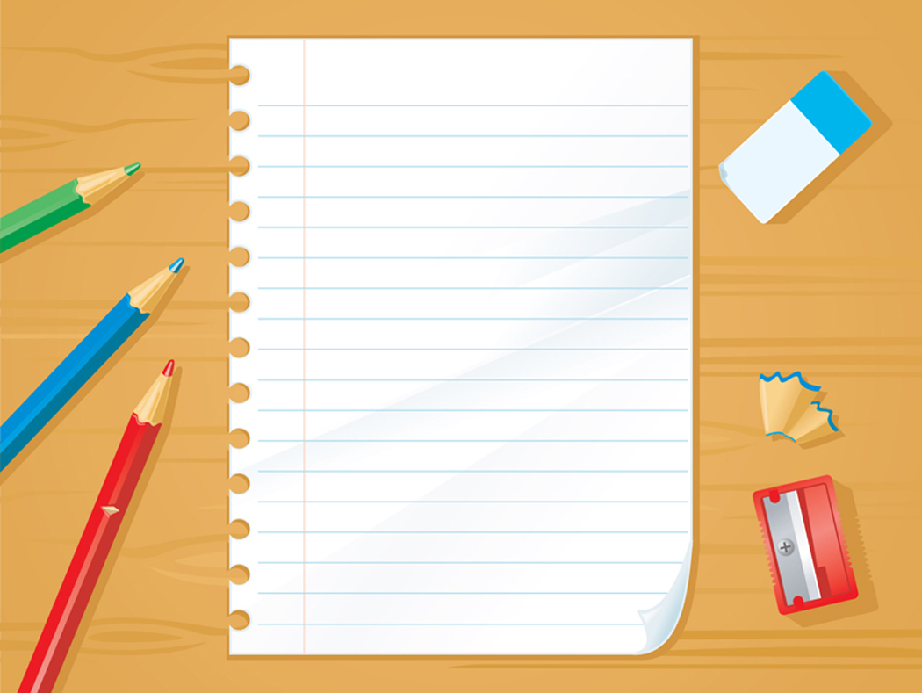

Preeceville School

Grade 6 2025/ 2026

Ms. Meghan Morton

* 3– 3 inch Binders (Zipper Binders Acceptable)
* 2- Packages of Loose Leaf
* 1- Package of Graph Paper
* 10 Dividers
* 3- Red Pen (No Gel Pens)
* 3- Blue Pen (No Gel Pens)
* 3- Black Pen (No Gel Pens)
* 2- 10 pack of HB Pencils (NO mechanical/ lead pencils)
* 2- White vinyl Erasers
* 1- White out (Tape or liquid)
* 1 – 30 cm (metric) ruler
* 2 – Glue sticks
* 1- Bottle of White Glue
* 1 - Set of sharpened Pencil Crayons
* 1- Package of Washable Markers
* 1- Fine Tipped Black Sharpie Marker
* 1- Pair of Scissors
* 1- Good Quality Geometry Set; this can be reused for upper level Maths.
* Dictionary – Gage Canadian Dictionary is good
* 3- Highlighters; different colors
* 1- Pencil Case (or pencil box)
* 1- Pencil Sharpener
* 1- Scientific Calculator (Does NOT need to be expensive; will be used again for upper level Maths.)
* 1- Pair of earphones/ headphones; placed in a labeled Zip Lock.
* 2 boxes of Kleenex (I will ask for more through the year if needed)
* Change of clothes for Phys.Ed (Shorts, T-shirt, socks, deodorant, runners (with non-marking soles) & a (small) gym bag.
* **Optional:** Refillable water bottle
  + ****Package of plastic forks/ spoons
  + Package of Band-Aids

**PLEASE LABEL ALL OF THE ABOVE ITEMS WITH YOUR CHILD’S NAME.**  
You are welcome to re-use any supplies that are in good shape.   
Please bring all supplies to school on the first day of school.

** Please check with your child during the year to see if they are running low on any supplies!**